**UNDP Audit Recommendation Tracking Tool**

**Version 1.3**

**Users Operational Manual Document**

**Date: 2nd December 2024**

Table of Contents

Introduction 4

1 Starting the Tool 5

1.1 The URLs 5

1.2 Credentials 5

2 Dashboard Module 5

2.1 Implementation Status Summary 5

2.2 Calendar Tracker 6

2.3 User Activities 6

3 Recommendations Module 7

3.1 New Recommendations 7

3.1.1 Prepare CSV 7

3.1.2 Upload CSV 7

3.1.3 Form Creation 8

3.2 View Recommendations Details 9

4 Reports Module 10

4.1 View Implementation Status Reports 10

4.2 View All and Remove Recommendations 10

4.3 View and Print Unimplemented Recommendations Report 11

4.4 Inquire or Send Messages 12

5 Action Plan Module 13

5.1 Create a New Action Plan 13

5.2 View Action Plan Details 14

5.3 Supervise Action Plan 14

5.3.1 Approve Plans 15

5.3.2 View Declined Plans 16

6 Tracking Module 17

6.1 Add Reports 17

6.1.1 CSV File Preparation 17

6.1.2 Upload Final Report’s Recommendations 17

6.2 View Reports Being Tracked, Due in 30 Days and Past Due Recommendations 18

6.3 Caution Recommendations 20

6.4 Change Implementation Status 21

6.5 Make Notes 22

7 Message Module 26

8 Notifications Module 27

8.1 View and Remove Notifications 27

9 Public Dashboard Module 28

9.1 Charts and The Menu Overview 28

9.2 Filter Options for Reports and Audits 28

9.3 Gender Mainstreaming Concept 29

9.3.1 Gender Mainstreaming Categories: 29

9.4 Generate Reports on the Public Dashboard 30

# Introduction

This manual is intended for users such as SAIs (Supreme Audit Institutions), client or lead bodies, and stakeholders who interact with the Audit Recommendations Tracking Tool. It offers detailed instructions on navigating the various modules of the tool, including the Dashboard Module, Recommendations Module, Reports Module, Action Plan Module, Tracking Module, Message Module, and Notifications Module.

The guide covers essential functions such as viewing implementation status summaries, managing new and existing recommendations, generating and interpreting reports, public dashboard overview, and supervising action plans. It also provides instructions for tracking reports, handling messages, and managing notifications to ensure efficient use of the tool and effective management of audit recommendations.

# Starting the Tool

## The URLs

* Once the tool has been hosted on the server by the Administrator, a link will be provided, which can be accessed through a browser.
* The link format is as follows:
  + https://127.0.0.1:8000/
  + The Administrator will provide the IP address (e.g., 127.0.0.1) along with the port number (e.g., 8000) for accessing the tool.

## Credentials

* The Administrator will create an account for each user of the tool, including a default password for initial login.
* On the login page, users can click the "Login" button to access the internal dashboard.
* The default password must be changed upon the first login.

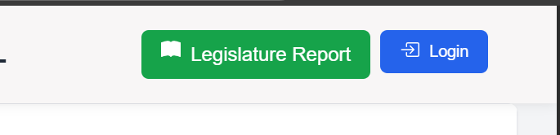

Figure 1:Login button on the public dashboard

# Dashboard Module

## Implementation Status Summary

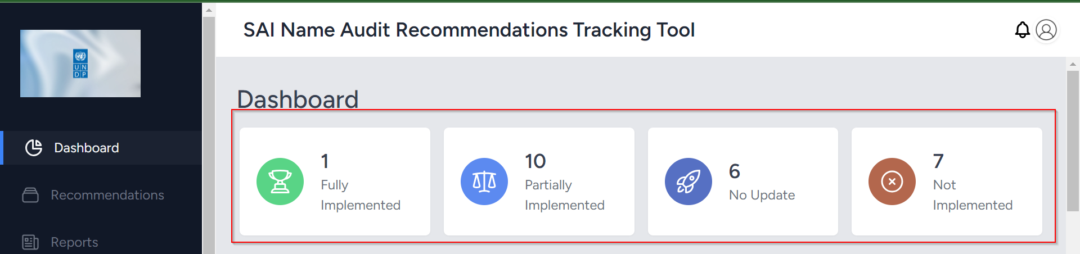

Figure 2: Implementation Status Statistics

## Calendar Tracker

Figure 3: Events Tracker Calendar

## User Activities

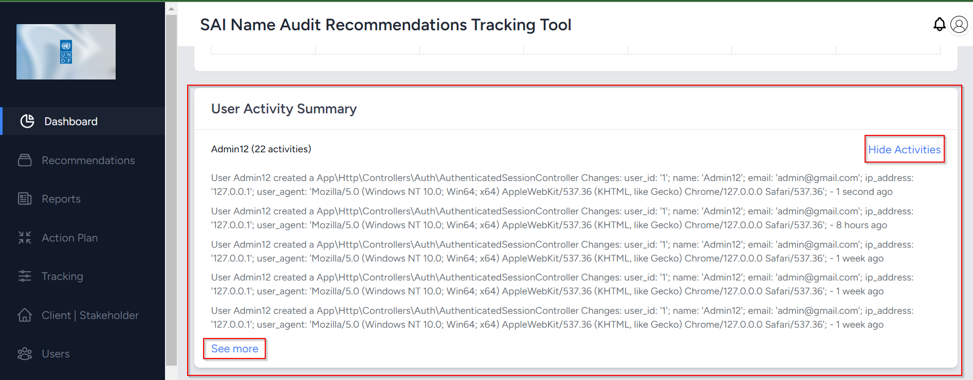

Figure 4: User Activities Detail

**Use**: To view the total number of each implementation status, view events or number of recommendations on the due dates, and view user activities.

**Steps**:

1. Login into the tool using credentials
2. Click or choose the **Dashboard** tab on the left menu
3. Scroll down to view the tracker – Use Next & Prev Buttons to see past and future due recommendations
4. Scroll to the bottom to view activities and click **More** to see all the activities

# Recommendations Module

## New Recommendations

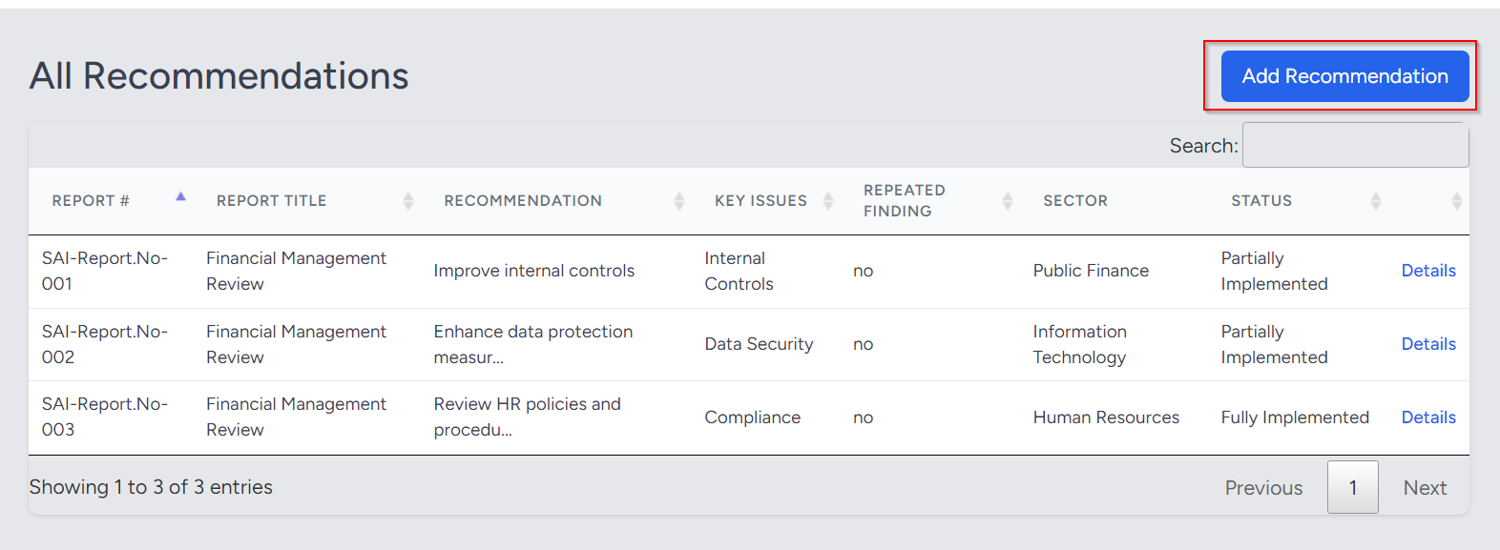

Figure 5: Under Recommendations Section, Click Add Button

**Use**: To add new recommendations that serve as the starting point of the action plan.

**Steps**:

1. Click the **Recommendations** tab
2. Then hit the **Add Recommendation** button to upload CSV or fill out the form.

### Prepare CSV

**Use**: To Prepare the recommendations in the CSV file for upload in the **Recommendations**

**Steps**:

1. Open the template CSV
2. Clear the contents while leaving the headers intact.
3. Add new relevant recommendation data corresponding to the headers

### Upload CSV

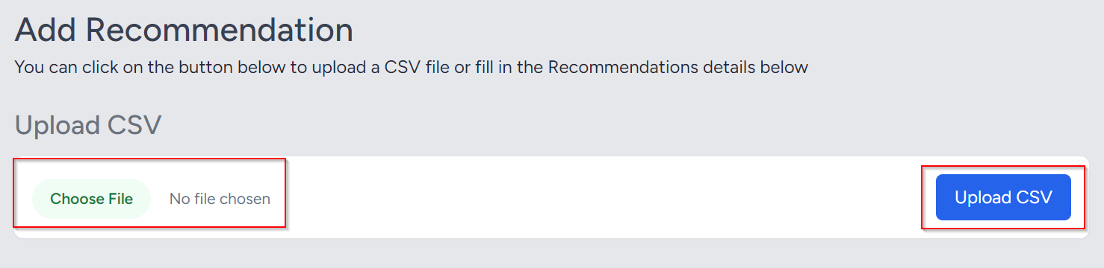

Figure 6: CSV Upload

**Use**: To add recommendations to the database for action plan execution.

**Steps**:

1. Select the prepared CSV file from its saved location.
2. Click the **Upload CSV** button to import the recommendations into the database.
3. View the detailed recommendations

### Form Creation

Figure 7: Using the form to create recommendations

**Use**: Add recommendations manually using the tool's form, located just below the CSV upload section.

**Steps**:

1. Enter the details of the recommendations in the fields of the form
2. Scroll down to locate and fill in any additional fields
3. Save the form after completing all the fields.

## View Recommendations Details

Figure 8: Viewing the details in the action section

**Use**: To view the details of the uploaded or created recommendations.

**Steps**:

1. In the **Recommendations** tab, scroll to the right and locate the "Details" action.
2. Click the "Details" link to view the details of each recommendation.

# Reports Module

## View Implementation Status Reports

Figure 9: Audit reports under each implementation status

**Use**: To view recommendations categorized by implementation status **Steps**:

1. Click on the **Reports** tab in the menu
2. Scroll down to view reports categorized by each status
3. Click on a report to see detailed recommendations
4. Alternatively, on the **Dashboard** menu, you can click the "Statistics" section to view summary reports by status

## View All and Remove Recommendations

Figure 10: Final reports recommendations viewing and deleting process start

Figure 11: Final reports recommendation’s view and delete

**Use**: To view and remove recommendations that are being tracked, which have passed the action plan stage.

**Steps**:

1. Under the Reports tab, click the **View|Delete Recommendations** button
2. Scroll down and across to view all the details of the recommendations
3. Scroll to the right to find the "Delete" button for any recommendation you wish to remove

## View and Print Unimplemented Recommendations Report

Figure 12: Unimplemented report viewing process start

Figure 13: Details of the unimplemented reports. The print to pdf option is present

**Use**: To view and print the recommendations that are not **Fully Implemented**.

**Steps**:

1. Under the **Reports** tab on the menu, click the **Unimplemented Report** button
2. Review the details of the recommendations that have not been fully implemented.
3. To print, click the **Print** button to generate a **PDF** for download.

## Inquire or Send Messages

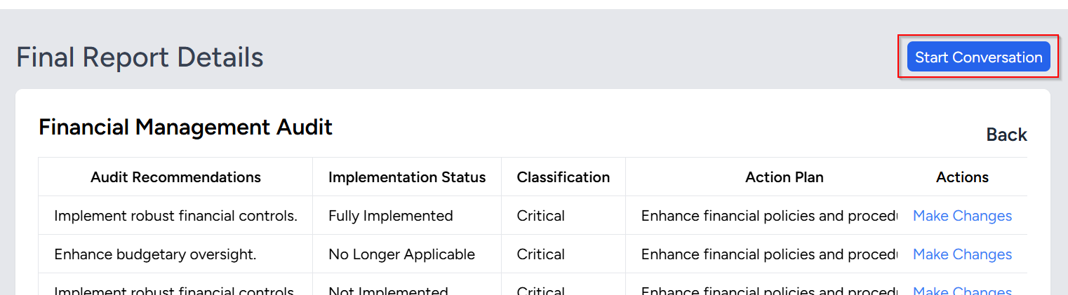

Figure 14: Sending the inquiry message

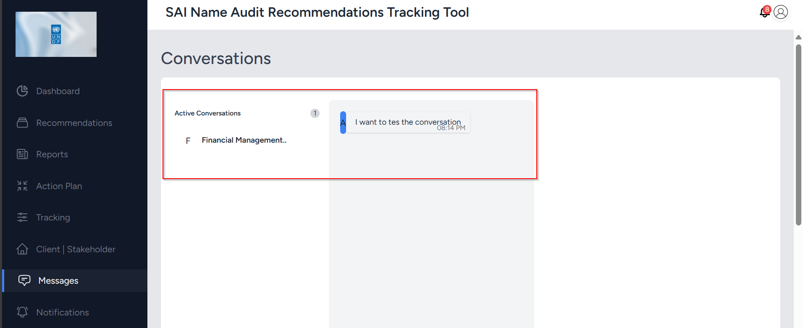

Figure 15: Conversation area

**Use**: Refer to Messages Module

# Action Plan Module

## Create a New Action Plan

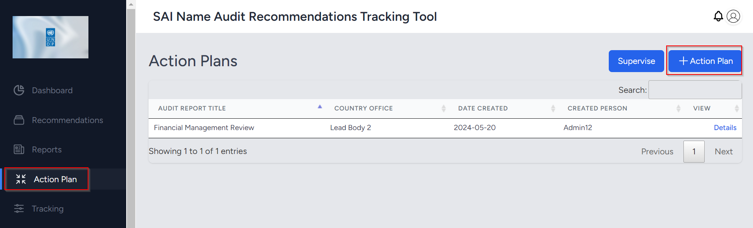

Figure 16: Action Plan creation process start

Figure 17: Action Plan form

**Use**: Create an action plan for audit reports uploaded to the **Recommendations** module

**Steps**:

1. In the Action Plan tab on the menu, click **+Action Plan** button
2. In the new window, containing a form, select the report that needs an action plan.
3. Enter and select the relevant details in the fields, then click **Save** at the bottom of the form to complete the process.

## View Action Plan Details

Figure 18: Action plan details viewing

**Use**: View the details of the action plan created.

**Steps**:

1. In the **Action Plan** section, locate the table listing reports with associated action plans.
2. Click the **Details** link in the last column on the right side of the table to view the details
3. The details will include all recommendations that have been applied to the action plan
4. Scroll across and down to view all the information

## Supervise Action Plan

Figure 19: Action plan supervision process start

### Approve Plans

Figure 20: Viewing the recommendations for the action planned report

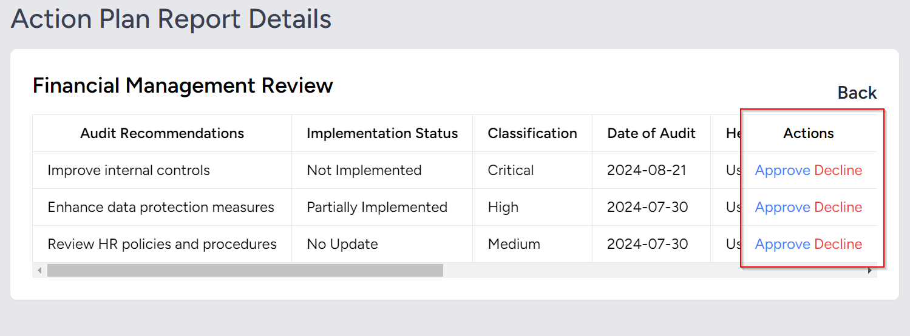

Figure 21: Approve and decline actions

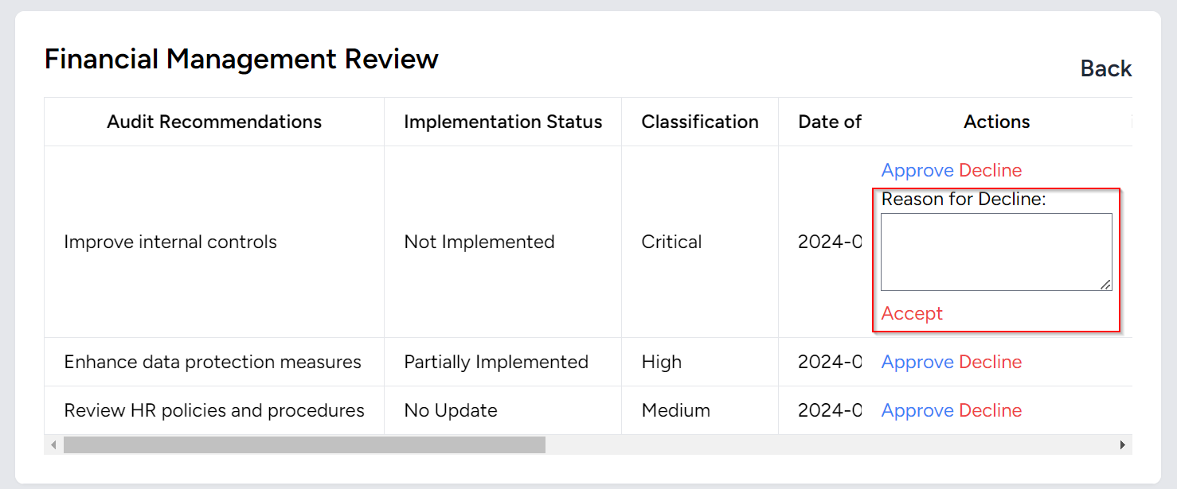

Figure 22: User to provide a reason for the decline

**Use**: To approve action plans created.

**Steps**:

1. In the **Action Plan** section, click the **Supervise** button.
2. In the next window, click on **View Recommendations**
3. Then click on the **Approve** option to supervise the action plan.
4. To reject the action plan, click **Decline**. You will be prompted to provide a reason for the rejection.

### View Declined Plans

Figure 23: Viewing actin plan declined reports

**Use**: To view action plans that were not approved.

**Steps**:

1. Click on the **Declined Action Plans** link
2. The details will show the reasons for the declined
3. The report may be resubmitted for approval once the issues have been resolved

# Tracking Module

## Add Reports

Figure 24: Final reports upload process start

### CSV File Preparation

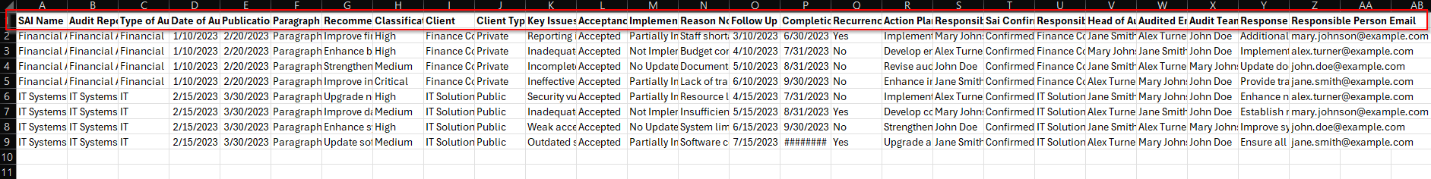

Figure 25: Sample recommendations to upload in CSV

Double Click this file to download the template and populate with audit recommendations details for upload in the next step

### Upload Final Report’s Recommendations

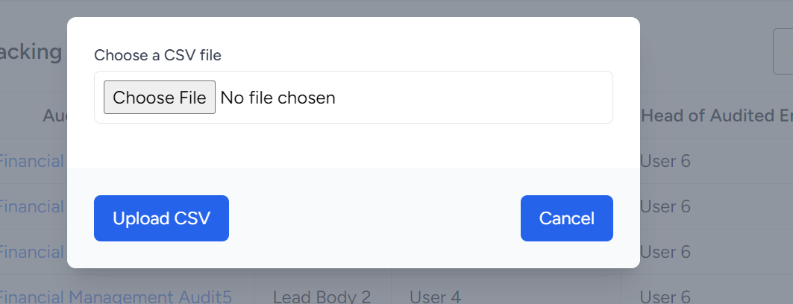

Figure 26: Modal to select the csv file

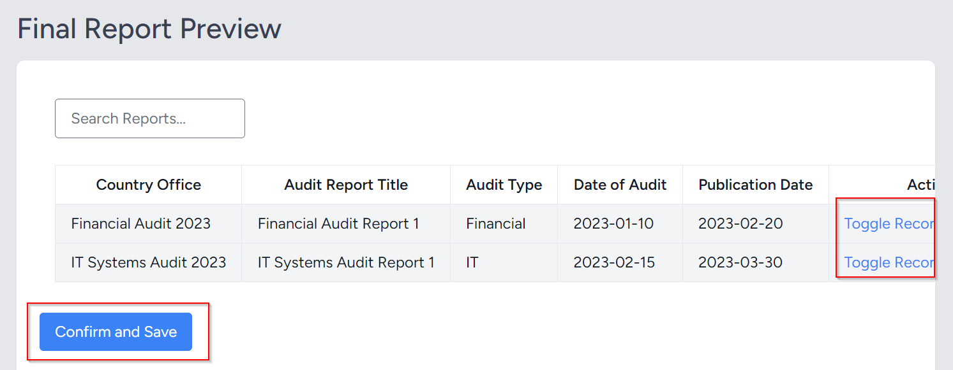

Figure 27: Preview - Toggle to view &make association. Confirm and Save button to complete the process

**Use**: To upload recommendations into the database for tracking

**Steps**:

1. In the tracking section, click the **Upload Final Report** button
2. Select the file you prepared from the saved location through the modal
3. Click the **Upload** button
4. In the preview, toggle through each report to view details and associate the relevant information in the provided fields.
5. Once done associating all the report recommendations, click **Confirm and Save** button to complete the process

## View Reports Being Tracked, Due in 30 Days and Past Due Recommendations



Figure 28: Reports with not fully implemented recommendations

Figure 29: Recommendations due in 30 days

Figure 30: Recommendations past due implementation days

**Use**: To view the progress of the implementation of recommendations.

**Steps**:

1. In the **Tracking** section, scroll down the page to review recommendations categorized in the tables.
2. In the first table, click on the name of a report to view its recommendation details

## Caution Recommendations

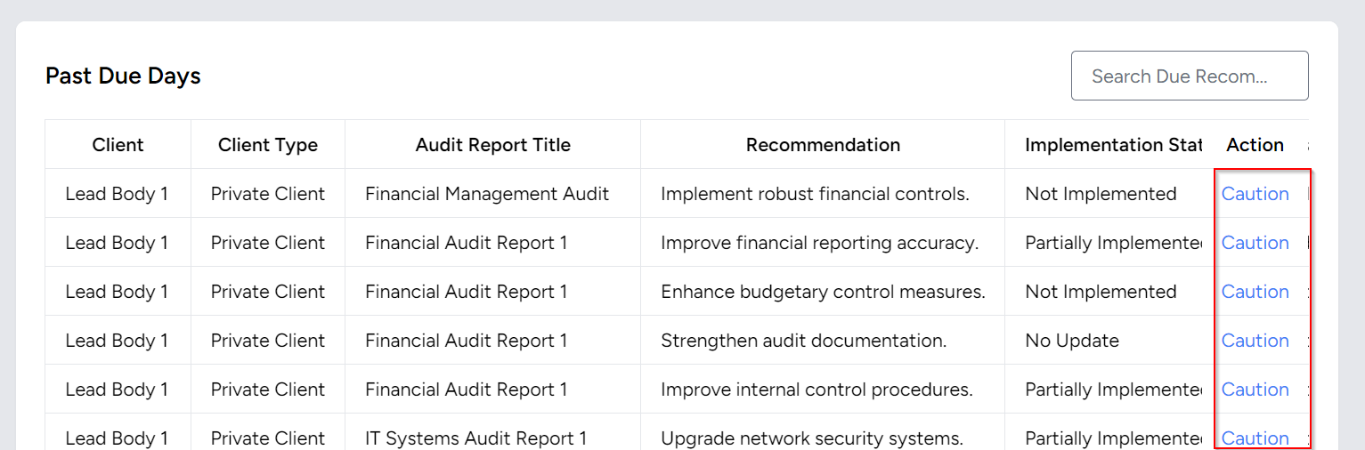

Figure 31: Caution process start

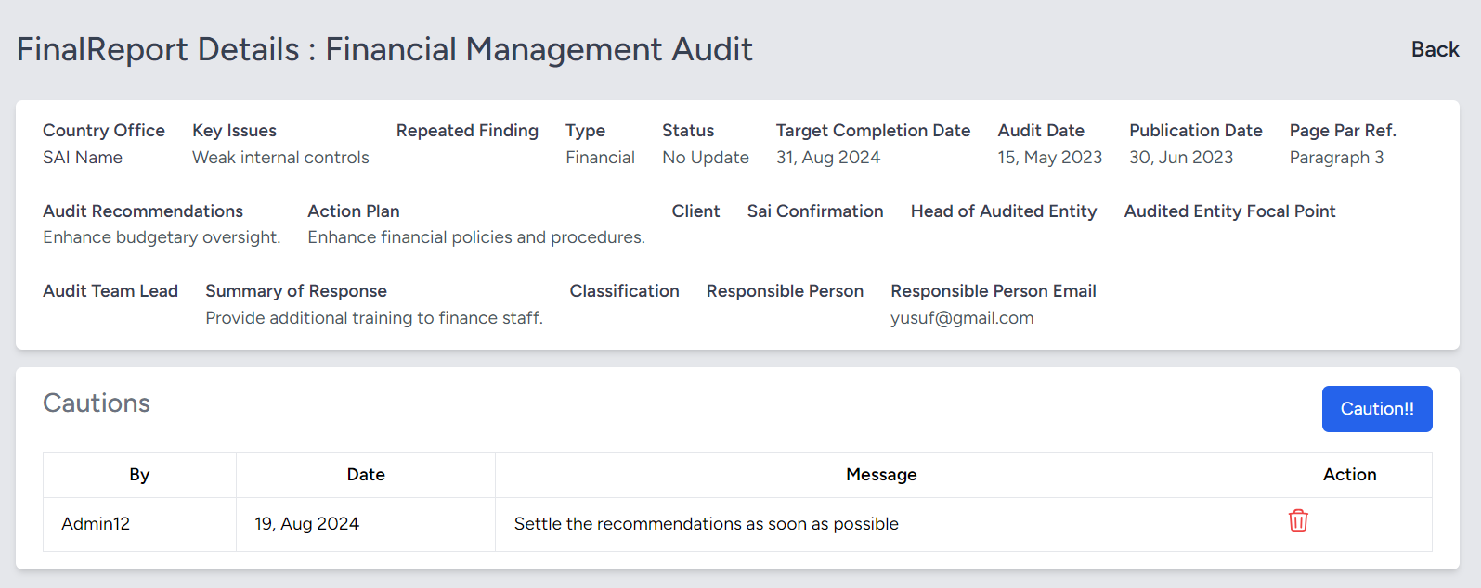

Figure 32: Caution process completion

**Use**: To warn responsible users about delays in implementing recommendations from the audit report.

**Steps**:

1. In the **Due in 30 Days** and **Past Due Days** table under **Tracking**, click on the caution action.
2. In the next window, add the caution by clicking on **Caution**! Button
3. A modal will pop up for you to enter your message.
4. To remove cautions, use the **Delete** button if they are no longer needed or if there was an error

## Change Implementation Status

Figure 33: Change status process start

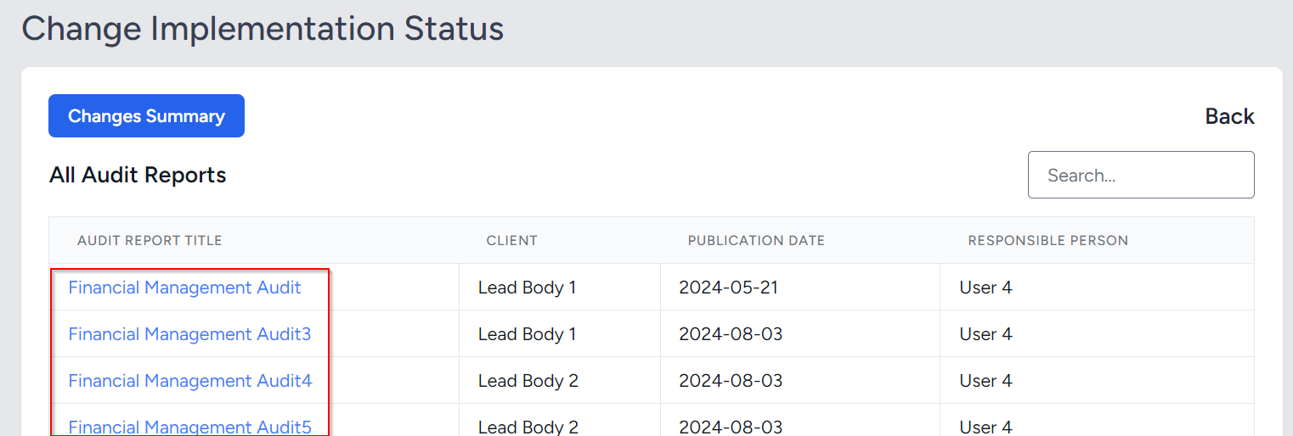

Figure 34: Selecting the report to apply changes

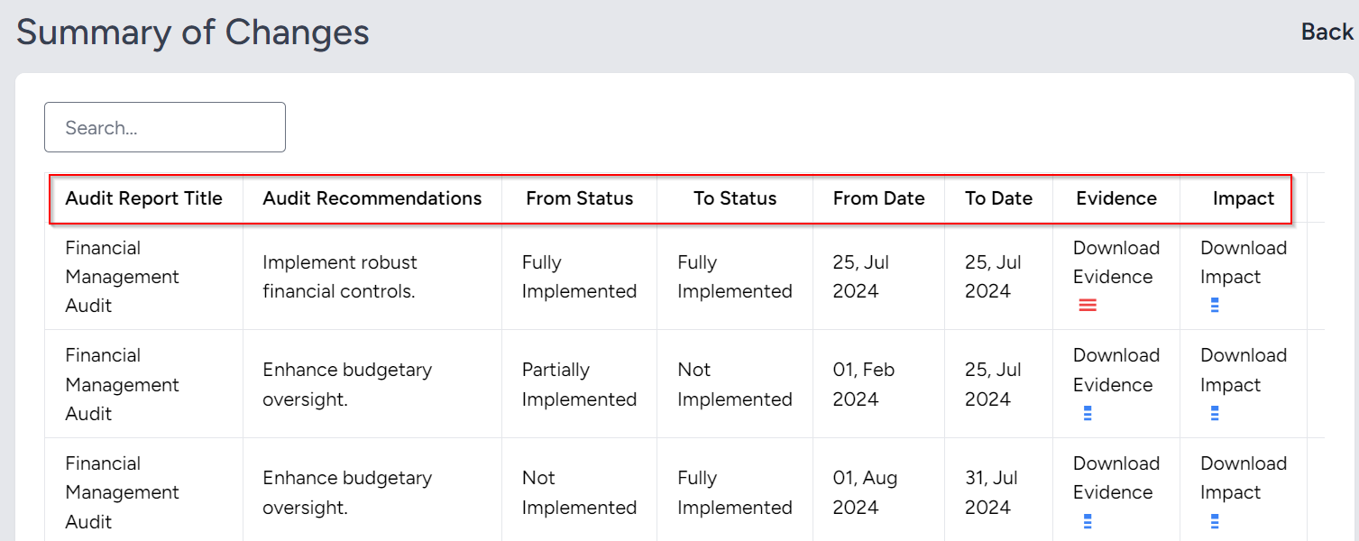

Figure 35: Changes summary

Figure 36: Selecting the recommendations to apply change

Figure 37: Changing status form

**Use**: To make changes to the status of recommendations in the Tracking section

**Steps**:

1. In the **Tracking** section, click on the **Change Status** button
2. In the next window, click the title of the report that requires a status change
3. Select the recommendation that must be changed the status
4. Update the due date and status, and upload PDFs for evidence and impact as supporting documents for the change
5. Click the **Update** button to complete the process
6. To view the summary of the changes, click on the **Change Summary** button next window after clicking the **Change Status** button in the **Tracking** section.

## Make Notes

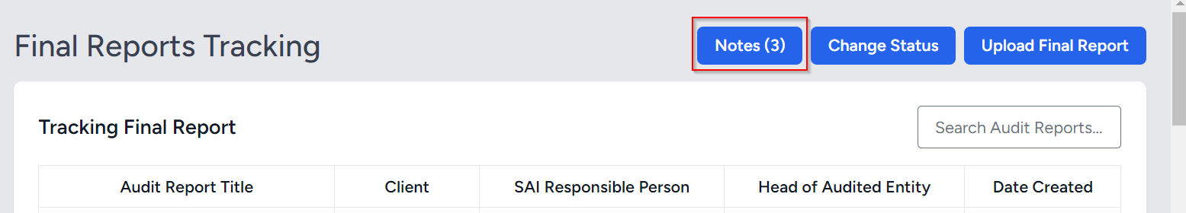

Figure 38: Note making process start

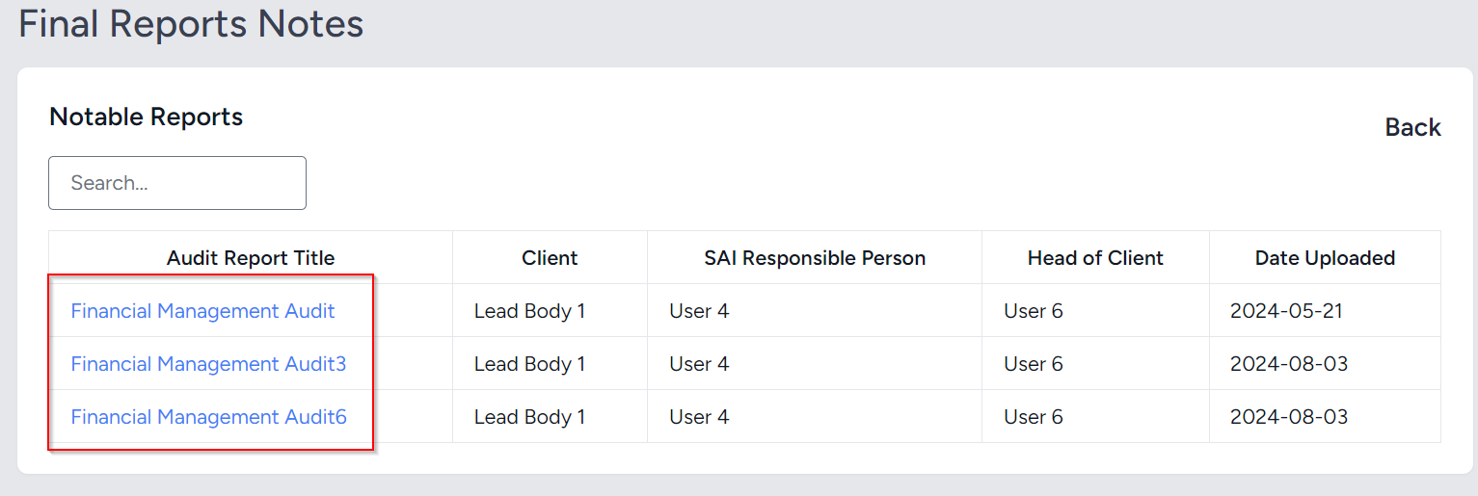

Figure 39: Select report title to make notes

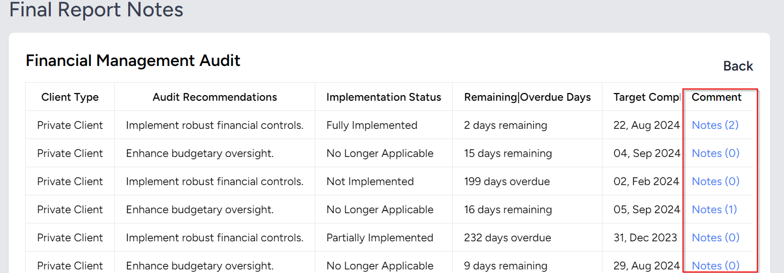

Figure 40: Choose a recommendation to note

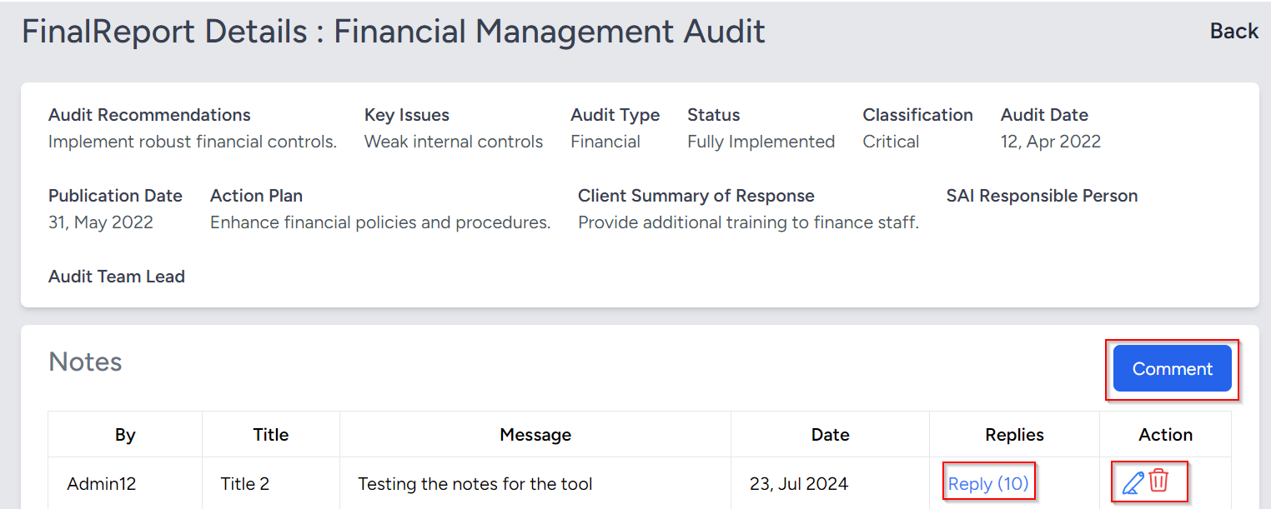

Figure 41: Comment, reply, delete, or edit the note

**Use**: To make comments or notes for the recommendations being tracked.

**Steps**:

1. In the **Tracking** section, click on the **Notes** button
2. Select the report title to which you want to add notes
3. Select the recommendation that needs to be noted or replied to
4. In the last window, use the **Comment** button to create a new note, reply to existing notes, and view the number of replies associated with each note
5. You can also edit or delete notes as needed
6. In the reply section, the modal will display previous replies, and you can create new replies as required.

# Message Module



Figure 42: Conversation start process

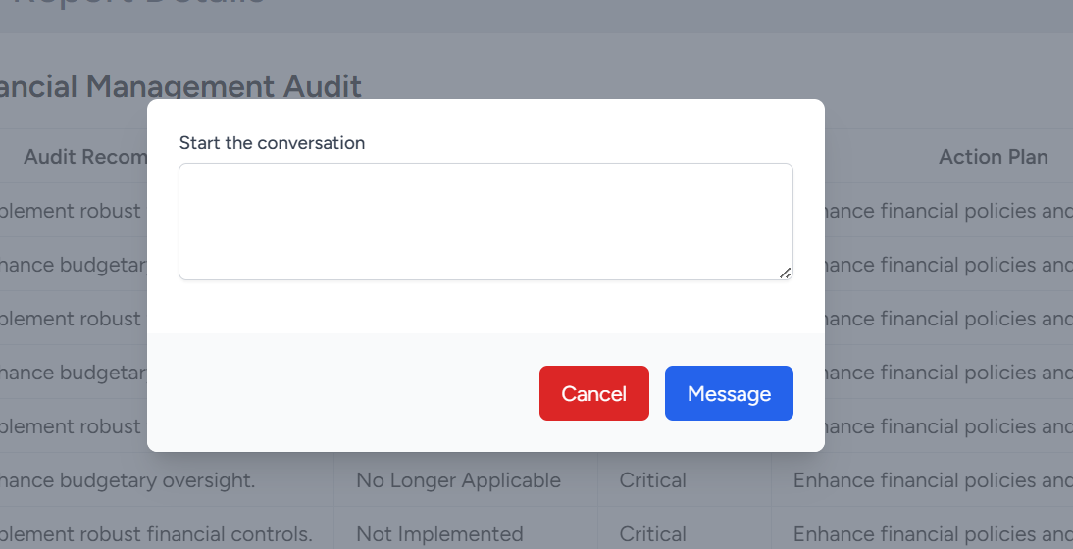

Figure 43: The field to write the message



Figure 44: The conversation window

**Use**: To view the conversation initiated by the stakeholder user on recommendations that are not Fully Implemented

**Steps**:

1. In the **Reports** section, view the report details. The **Start Conversation** button will appear in the report details.
2. Click the **Start Conversation** button to open a modal where you can input your message
3. Responsible personnel will receive a notification, and the conversation will appear in the **Message** tab section
4. Other users can reply to the conversation, and these replies will be visible in the chat.

# Notifications Module

## View and Remove Notifications

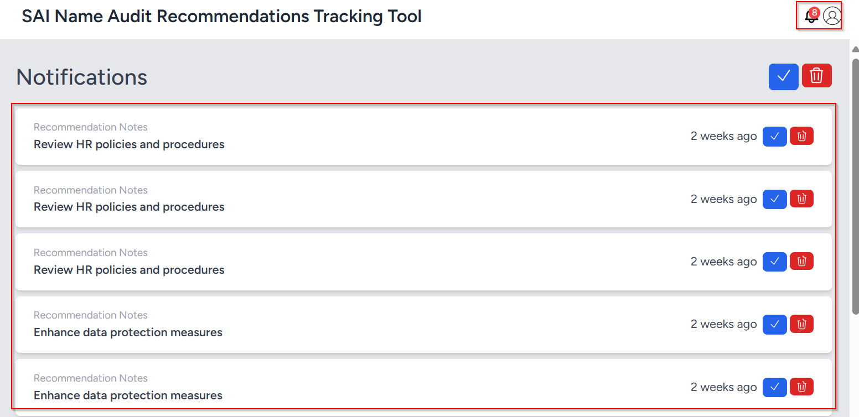

Figure 45: Notifications overview

**Use**: To view and delete the notifications generated by the system

**Steps**:

1. Click on the **Notifications** tab or **Icon** in the right top corner of the tool
2. A list of notifications generated will appear for viewing and further action
3. Notifications can be viewed or deleted using the respective icons

# Public Dashboard Module

## Charts and The Menu Overview

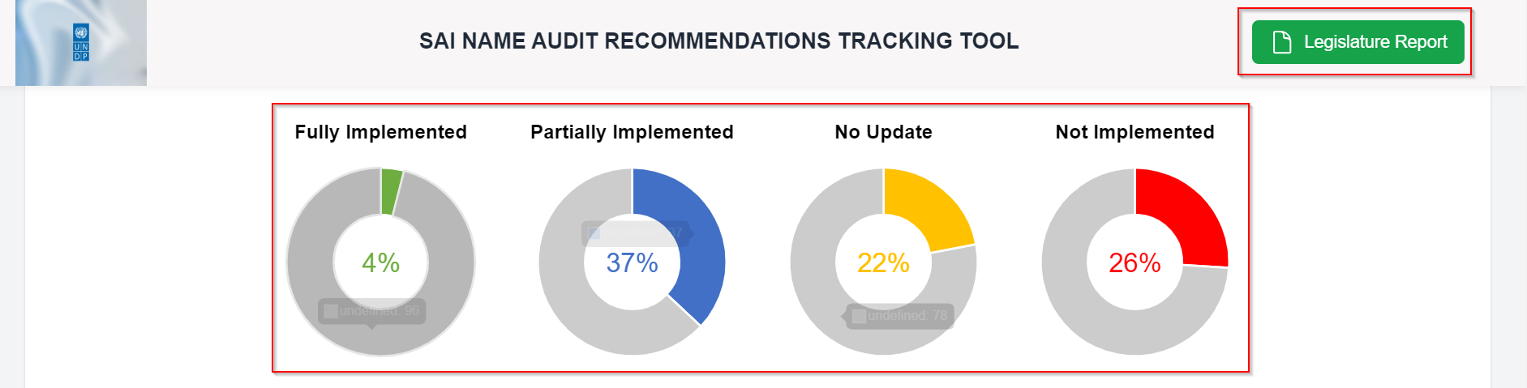

Figure 46: The implementation status charts

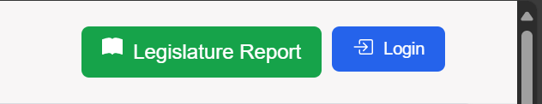

Figure 47: Legislature report and login button

## Filter Options for Reports and Audits

1. **Client**: Filters by the client or office associated with the items.
2. **Report Title**: Filters by the title of the report.
3. **Status**: Filters based on the implementation status of the report (e.g., Fully Implemented, Not Implemented, etc.).
4. **Repeated Findings**: Filters based on whether the findings are repeated in the report (Yes or No).
5. **Audit Type**: Filters based on the type of audit (e.g., Financial, Performance, Compliance).
6. **Client Type**: Filters based on the type of client.
7. **Publication Date**: Filters based on the report's publication date within a specified date range.

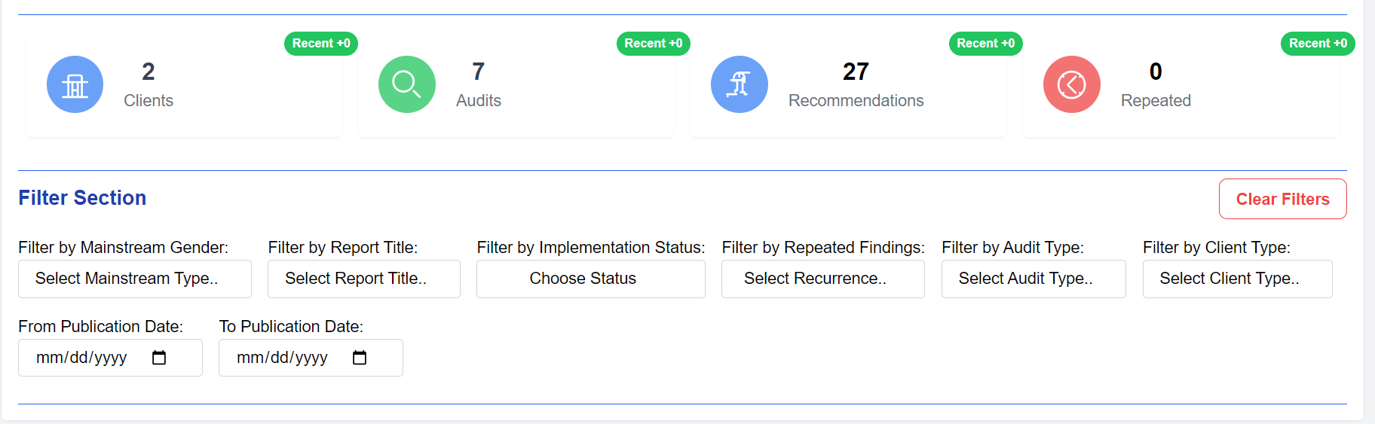

Figure 48: Summary and filter section

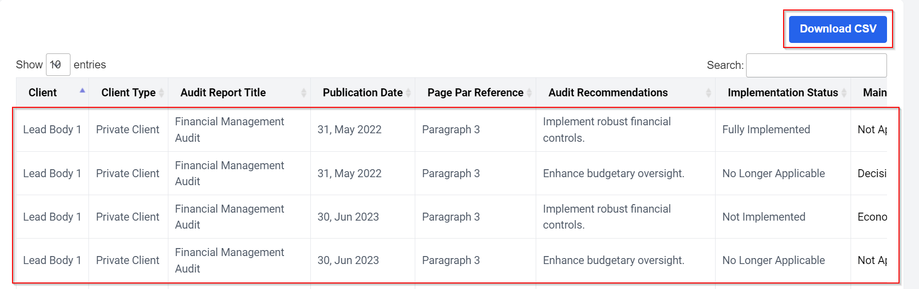

Figure 49: Recommendations table

**Use**: To provide summarized details of the reports and their recommendations being tracked, and to offer downloadable reports in PDF and CSV formats.

**Steps**:

1. First, use the **Legislature** **Report** button for essential actions related to PDF report.
2. Next, navigate to the chart section for visual summaries
3. Then, review the summary and filter section to refine and summarize the data
4. Finally, consult the table that contains detailed information about the recommendations being tracked.
5. The table includes a **CSV Download** button for downloading the filtered items in CSV format

## Gender Mainstreaming Concept

Gender mainstreaming is the process of incorporating gender perspectives into all policies, programs, and activities to promote equality and address gender disparities. It ensures that the needs and experiences of all genders are considered, fostering equal opportunities and outcomes.

### Gender Mainstreaming Categories:

1. **Economic Autonomy**  
   The ability for women to generate their own income, access paid work under equal conditions with men, and make independent financial decisions. It includes control over resources and social security, with attention to how unpaid care work limits economic participation.
2. **Physical Autonomy**  
   The right for women to make decisions about their own bodies, free from violence, and to control aspects of their reproductive health. This includes the right to live without gender-based violence and to make choices about sexuality and reproduction.
3. **Decision-making Autonomy**  
   The equal participation of women and men in decision-making processes at all levels, ensuring women can access leadership and power positions. This includes promoting women's full involvement in politics, governance, and legal frameworks.

Steps to Incorporate Mainstream Gender in the Recommendations

1. Prepare a CSV final report
2. In the tracking tab, click on the “Upload Final Report” button
3. In the pop-up window, select the CSV report and upload it.
4. In the preview, if the recommendation in each report includes gender mainstreaming, toggle and associate the relevant gender mainstreaming category. Otherwise, select the "Not Applicable" option from the dropdown.

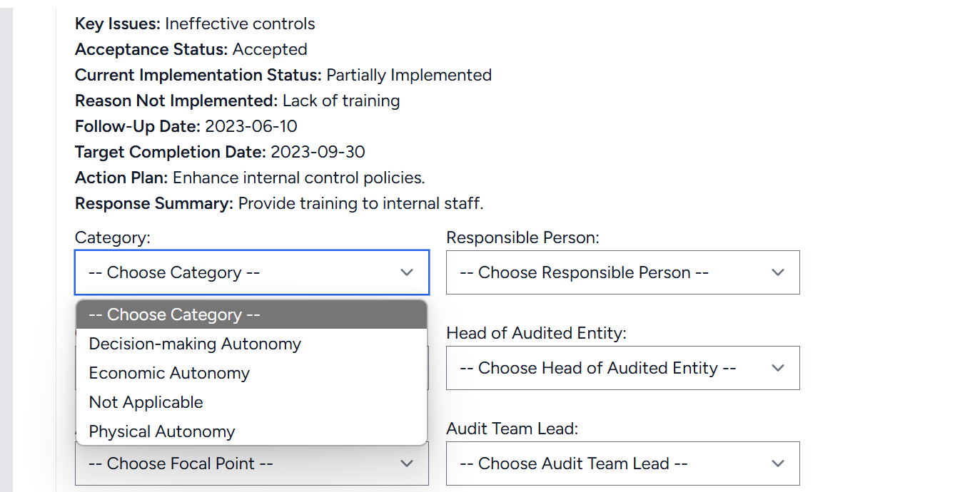

Figure 50: Mainstream Gender Incorporation

## Generate Reports on the Public Dashboard

1. **To generate a Legislature Report (PDF)**:  
   Click on the **Legislature Report** button in the menu item. This will generate the comprehensive report in PDF format.

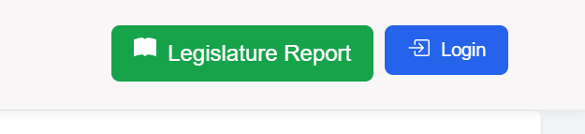

Figure 51: Legislature Report Button

1. **To download the Final Report (CSV)**:  
   Click on the **Download CSV** button to download the CSV report containing the final recommendations.

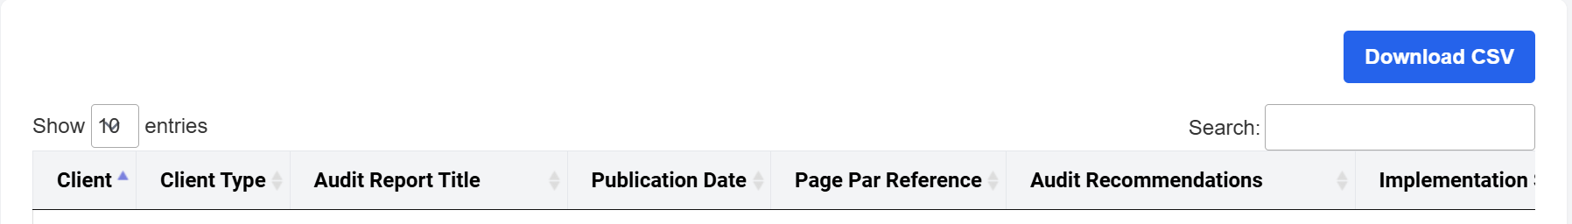

Figure 52: CSV Report Button

**The End**